
Cheryl Stone New Year’s Eve Teams
Thursday 31st December 2026
Enter via myABF: 80 Bridge credits per team
Commencing: 4 PM
Finishing: Approx 8 PM
Entries Close: Tuesday 29th December 6 PM
Theme: Dress as your favourite sportsperson
Cheryl was one of the Broncos’ biggest fans
Please bring a savoury plate to share
Farewell 2026 with Bridge, snacks and complimentary wine.
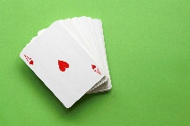
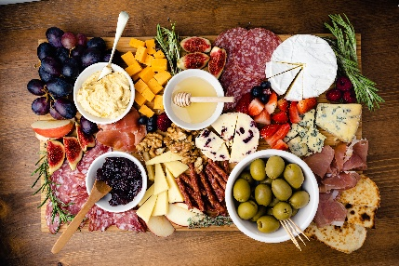 Prizes and Red Masterpoints
Any enquiries, help with teammates, please contact Debbie Carroll on 041 300 1326 or Robyn Clark on 0414540776
This event is conducted under QBA Regulation
Queensland Contract Bridge Club
67 Ipswich Road, Woolloongabba 4102
Ph: 3391 3241 Email: manager.qcbc@outlook.com

