 | 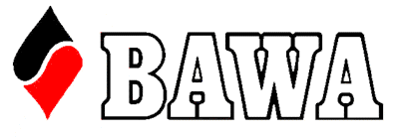

GNOT METRO
2024 FINAL
ENTRY QUALIFICATION THROUGH
METROPLOLITAN CLUB EVENTS.
Gold Point Event
10th and 11th AUGUST 2024
CITY OF MELVILLE BRIDGE CLUB
1.00 PM SATURDAY
10.00 AM SUNDAY

ENTER BY MYABF
http://myabf.com.au/go/2024GNOTMetroFinal
$240.00 PER TEAM

Please note this year the National Qualifying Finals shall be held Online (RealBridge) over a 3 day weekend (Friday September 20th through Sunday September 22nd). Please note if the team is contending or not to the TO at the event.
See 2024 Grand National Open Teams (abfevents.com.au) for full conditions
and Phase Three Face to face Finals.
BAWA shall pay the $300 entry fee to this event.
TO Robina McConnell
Phone 0400943367

