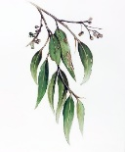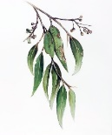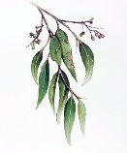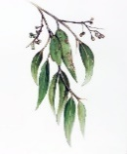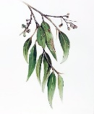
BAWA 2024 COUNTRY
CHAMPIONSHIPS
at BRIDGETOWN
Red Point Event
September 7th & 8th
Saturday – 9:30 am Duplicate Pairs. Sunday – 9:00 am Swiss Teams
VENUE: Bridgetown Gardens Function Centre
Robinia Way, Kangaroo Gully, Bridgetown
https://www.myabf.com.au/go/CC24
ENTRIES – MyAbf COST - $50 per person per day
(Morning and afternoon teas provided both days.)
NOTE: LUNCH NOT PROVIDED (PLEASE BRING YOUR OWN)
DIRECTOR: BRIAN WADE - Ph: 0427133747. hwade@bigpond.com
CONVENOR: Josephine Dundas – Ph: 0411477194.
josephinedundas607@gmail.com
ELIGIBILTY CRITERIA TO BE A COUNTRY PLAYER:
All members of the following 12 clubs who declare they are permanent residents of the said region are eligible: Albany, Avon Valley, Bridgetown, Bunbury, Busselton, Denmark, Esperance, Geraldton, Kalgoorlie, Kendenup, Kojonup, Mandurah. The Metropolitan Area is defined as: the area bounded by Rockingham to the south, Mundaring to the East, and Yanchep to the North, or as determined from time to time by Council.
By entering the event entrants are affirming their eligibility to play as a Country player. BAWA Regulations Apply.
