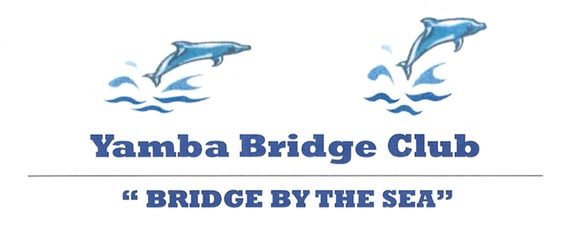

ANNUAL SWISS PAIRS CONGRESS
Will be held at
Yamba Bowling Club,
44 Wooli Street, Yamba

On 25th & 26th May, 2024

Director: Ronnie Ng

Entries close 7th May

Conducted under the auspices of NSWBA.
All players are subject to the NSWBA’s Congress
Disciplinary Regulations.
The ABF has approved the level of Red Masterpoints at level B4.

PROGRAMME
Saturday 25th May
9:30am Registration
10:00am 1st Session (3x8 board matches)
Lunch
2:00pm 2nd Session (4x8 board matches)

Sunday 26th May
9:00am 3rd Session (4x8 board matches)
End of Play
Lunch & Presentations

Systems: Green & Blue Systems only.
All players must have systems card.

Prizes: Cash & other prizes to be awarded.
Entry Fee: $110 per person
Payment: via ABF website or Direct Deposit
EFT DETAILS:
BSB 533 000
Account Number 021 329 09
Reference Surname+ABF Number
Enquiries: Tracy Harris
Tracy58@gmail.com

